Perform the following activity in R:

→ Build a decision tree for the ‘iris’ data with function ‘ctree()’ in package “party”.

**Ans :**

**R Code :**

## Decision Trees

########## Iris Data Set #########

data("iris")

#install.packages("caret")

#install.packages("C50")

library(caret)

library(C50)

inTraininglocal <- createDataPartition(iris$Species,p=.70,list=F)

training <- iris[inTraininglocal,]

testing <- iris[-inTraininglocal,]

#Model Building

model <- C5.0(training$Species~.,data=training)

#Generate the model summary

summary(model)

#Predict the test data set

pred <- predict.C5.0(model,testing[,-5])

a <- table(testing$Species,pred)

sum(diag(a))/sum(a)

plot(model)

#### Boosting

inTraininglocal <- createDataPartition(iris$Species,p=.70,list=F)

training <- iris[inTraininglocal,]

testing <- iris[-inTraininglocal,]

#Model Building

model <- C5.0(training$Species~.,data=training,trials=20) #Trials - Boosting parameters

#Generate the model summary

summary(model)

#Predict the test data set

pred <- predict.C5.0(model,testing[,-5])

a <- table(testing$Species,pred)

sum(diag(a))/sum(a)

plot(model)

##### Bagging

acc <- c()

for (i in 1:100)

{

print(i)

##Data Partition

inTraininglocal <- createDataPartition(iris$Species,p=.70,list=F)

training1 <- iris[inTraininglocal,]

testing <- iris[-inTraininglocal,]

## Model Building

fittree <- C5.0(training1$Species~.,data=training1)

#Predicting

pred <- predict.C5.0(fittree,testing[,-5])

a<-table(testing$Species,pred)

#Accuracy

acc<-c(acc,sum(diag(a))/sum(a))

}

summary(acc)

boxplot(acc)

##### Bagging and Boosting

acc <- c()

for (i in 1:100)

{

print(i)

##Data Partition

inTraininglocal <- createDataPartition(iris$Species,p=.70,list=F)

training1 <- iris[inTraininglocal,]

testing <- iris[-inTraininglocal,]

## Model Building

fittree <- C5.0(training1$Species~.,data=training1,trials=20)

#Predicting

pred <- predict.C5.0(fittree,testing[,-5])

a<-table(testing$Species,pred)

#Accuracy

acc<-c(acc,sum(diag(a))/sum(a))

}

summary(acc)

boxplot(acc)

**Results :**

> summary(model)

Call:

C5.0.formula(formula = training$Species ~ ., data = training)

C5.0 [Release 2.07 GPL Edition] Wed Apr 29 15:57:07 2020

-------------------------------

Class specified by attribute `outcome'

Read 105 cases (5 attributes) from undefined.data

Decision tree:

Petal.Length <= 1.9: setosa (35)

Petal.Length > 1.9:

:...Petal.Width > 1.7: virginica (30)

Petal.Width <= 1.7:

:...Petal.Length <= 4.9: versicolor (34/1)

Petal.Length > 4.9: virginica (6/2)

Evaluation on training data (105 cases):

Decision Tree

----------------

Size Errors

4 3( 2.9%) <<

(a) (b) (c) <-classified as

---- ---- ----

35 (a): class setosa

33 2 (b): class versicolor

1 34 (c): class virginica

Attribute usage:

100.00% Petal.Length

66.67% Petal.Width

Time: 0.0 secs

> sum(diag(a))/sum(a)

[1] 0.9777778

> model <- C5.0(training$Species~.,data=training,trials=20) #Trials - Boosting parameters

> #Generate the model summary

> summary(model)

Call:

C5.0.formula(formula = training$Species ~ ., data = training, trials = 20)

C5.0 [Release 2.07 GPL Edition] Wed Apr 29 15:57:45 2020

-------------------------------

Class specified by attribute `outcome'

Read 105 cases (5 attributes) from undefined.data

----- Trial 0: -----

Decision tree:

Petal.Length <= 1.9: setosa (35)

Petal.Length > 1.9:

:...Petal.Width > 1.7: virginica (30)

Petal.Width <= 1.7:

:...Petal.Length <= 4.9: versicolor (35/1)

Petal.Length > 4.9: virginica (5/1)

----- Trial 1: -----

Decision tree:

Petal.Length <= 1.9: setosa (26.4)

Petal.Length > 1.9:

:...Petal.Width > 1.7: virginica (22.6)

Petal.Width <= 1.7:

:...Sepal.Length <= 4.9: virginica (14.4/0.8)

Sepal.Length > 4.9:

:...Petal.Length <= 5: versicolor (39.3/0.8)

Petal.Length > 5: virginica (2.3)

----- Trial 2: -----

Decision tree:

Petal.Length <= 1.9: setosa (19.9)

Petal.Length > 1.9:

:...Petal.Width <= 1.4: versicolor (28.3/0.6)

Petal.Width > 1.4: virginica (56.8/14.8)

----- Trial 3: -----

Decision tree:

Petal.Length <= 1.9: setosa (15.8)

Petal.Length > 1.9:

:...Petal.Length > 5: virginica (14.6)

Petal.Length <= 5:

:...Sepal.Width > 2.5: versicolor (38.6/1.4)

Sepal.Width <= 2.5:

:...Petal.Width <= 1.4: versicolor (13.9)

Petal.Width > 1.4: virginica (22.2/2.4)

----- Trial 4: -----

Decision tree:

Petal.Length <= 1.9: setosa (12)

Petal.Length > 1.9:

:...Petal.Width > 1.7: virginica (28.9)

Petal.Width <= 1.7:

:...Sepal.Width > 2.6: versicolor (28.3/0.7)

Sepal.Width <= 2.6:

:...Petal.Length <= 4.7: versicolor (25.9/6.2)

Petal.Length > 4.7: virginica (10)

----- Trial 5: -----

Decision tree:

Petal.Length <= 1.9: setosa (9.2)

Petal.Length > 1.9:

:...Petal.Length <= 4.4: versicolor (12.9)

Petal.Length > 4.4:

:...Petal.Width > 1.7: virginica (22.2)

Petal.Width <= 1.7:

:...Petal.Length > 5: virginica (17.3)

Petal.Length <= 5:

:...Sepal.Length <= 6: virginica (23.1/3.1)

Sepal.Length > 6: versicolor (20.3)

----- Trial 6: -----

Decision tree:

Petal.Width <= 0.6: setosa (7)

Petal.Width > 0.6:

:...Petal.Length > 4.7: virginica (41.2/6.6)

Petal.Length <= 4.7:

:...Petal.Width <= 1.6: versicolor (46.3)

Petal.Width > 1.6: virginica (10.4)

----- Trial 7: -----

Decision tree:

Petal.Length <= 1.9: setosa (5.3)

Petal.Length > 1.9:

:...Petal.Width > 1.7: virginica (12.9)

Petal.Width <= 1.7:

:...Petal.Length > 5: virginica (10.1)

Petal.Length <= 5:

:...Sepal.Width <= 2.5: virginica (20.1/8.5)

Sepal.Width > 2.5: versicolor (56.6)

----- Trial 8: -----

Decision tree:

Petal.Length <= 1.9: setosa (4.1)

Petal.Length > 1.9:

:...Petal.Width > 1.6: virginica (26.2/10)

Petal.Width <= 1.6:

:...Petal.Length <= 4.9: versicolor (64.2)

Petal.Length > 4.9: virginica (10.6)

----- Trial 9: -----

Decision tree:

Petal.Width > 1.7: virginica (7.7)

Petal.Width <= 1.7:

:...Petal.Length > 5: virginica (6)

Petal.Length <= 5:

:...Petal.Length <= 1.9: setosa (3.2)

Petal.Length > 1.9: versicolor (88.1/7)

----- Trial 10: -----

Decision tree:

Petal.Width <= 1.4: versicolor (25/2.8)

Petal.Width > 1.4:

:...Sepal.Width <= 2.9: virginica (38/4.1)

Sepal.Width > 2.9:

:...Petal.Width <= 1.7: versicolor (38.1/2.1)

Petal.Width > 1.7: virginica (3.9)

----- Trial 11: -----

Decision tree:

Petal.Length <= 1.9: setosa (22)

Petal.Length > 1.9:

:...Petal.Width <= 1.3: versicolor (14.1)

Petal.Width > 1.3:

:...Sepal.Width <= 2.7: virginica (29.6/4.3)

Sepal.Width > 2.7:

:...Petal.Length <= 5: versicolor (33.8/2.1)

Petal.Length > 5: virginica (5.5)

----- Trial 12: -----

Decision tree:

Petal.Length <= 1.9: setosa (16.8)

Petal.Length > 1.9:

:...Petal.Width > 1.7: virginica (15.5)

Petal.Width <= 1.7:

:...Sepal.Length <= 4.9: virginica (11.7/2.1)

Sepal.Length > 4.9: versicolor (60.9/12.1)

----- Trial 13: -----

Decision tree:

Petal.Length <= 1.9: setosa (13.3)

Petal.Length > 1.9:

:...Petal.Length <= 4.4: versicolor (16.2)

Petal.Length > 4.4:

:...Sepal.Length <= 6.1: virginica (39.5/4.7)

Sepal.Length > 6.1:

:...Petal.Length <= 5: versicolor (24.3/0.7)

Petal.Length > 5: virginica (11.7)

----- Trial 14: -----

Decision tree:

Petal.Length <= 1.9: setosa (10.1)

Petal.Length > 1.9:

:...Petal.Width > 1.7: virginica (15.4)

Petal.Width <= 1.7:

:...Petal.Length <= 5: versicolor (67.6/14.8)

Petal.Length > 5: virginica (11.8)

----- Trial 15: -----

Decision tree:

Petal.Length <= 1.9: setosa (8)

Petal.Length > 1.9:

:...Petal.Width <= 1.4: versicolor (24/2.7)

Petal.Width > 1.4:

:...Sepal.Width <= 2.9: virginica (47.2/5.1)

Sepal.Width > 2.9: versicolor (25.8/10.4)

----- Trial 16: -----

Decision tree:

Petal.Length <= 1.9: setosa (6.4)

Petal.Length > 1.9:

:...Petal.Length > 4.7: virginica (57.5/7.2)

Petal.Length <= 4.7:

:...Petal.Width <= 1.6: versicolor (28.8)

Petal.Width > 1.6: virginica (12.2)

----- Trial 17: -----

Decision tree:

Petal.Length <= 1.9: setosa (4.9)

Petal.Length > 1.9:

:...Petal.Width > 1.7: virginica (19.4)

Petal.Width <= 1.7:

:...Sepal.Width <= 2.6: virginica (31.8/8.4)

Sepal.Width > 2.6:

:...Petal.Length <= 5: versicolor (43.6)

Petal.Length > 5: virginica (5.2)

----- Trial 18: -----

Decision tree:

Petal.Width <= 1.3: versicolor (30.8/3.8)

Petal.Width > 1.3:

:...Petal.Width > 1.7: virginica (15)

Petal.Width <= 1.7:

:...Sepal.Width <= 2.6: virginica (24.3/6.3)

Sepal.Width > 2.6: versicolor (34.8/4)

----- Trial 19: -----

Decision tree:

Petal.Length <= 1.9: setosa (21.5)

Petal.Length > 1.9:

:...Petal.Length > 5: virginica (12.8)

Petal.Length <= 5:

:...Petal.Width <= 1.4: versicolor (29.2)

Petal.Width > 1.4:

:...Sepal.Length <= 6.1: virginica (19.1/2.7)

Sepal.Length > 6.1: versicolor (22.4/1.9)

Evaluation on training data (105 cases):

Trial Decision Tree

----- ----------------

Size Errors

0 4 2( 1.9%)

1 5 2( 1.9%)

2 3 10( 9.5%)

3 5 4( 3.8%)

4 5 3( 2.9%)

5 6 3( 2.9%)

6 4 3( 2.9%)

7 5 9( 8.6%)

8 4 1( 1.0%)

9 4 2( 1.9%)

10 4 39(37.1%)

11 5 4( 3.8%)

12 4 5( 4.8%)

13 5 8( 7.6%)

14 4 2( 1.9%)

15 4 23(21.9%)

16 4 3( 2.9%)

17 5 11(10.5%)

18 4 38(36.2%)

19 5 5( 4.8%)

boost 0( 0.0%) <<

(a) (b) (c) <-classified as

---- ---- ----

35 (a): class setosa

35 (b): class versicolor

35 (c): class virginica

Attribute usage:

100.00% Petal.Length

100.00% Petal.Width

66.67% Sepal.Length

66.67% Sepal.Width

Time: 0.0 secs

> #Predict the test data set

> pred <- predict.C5.0(model,testing[,-5])

> a <- table(testing$Species,pred)

> sum(diag(a))/sum(a)

[1] 0.9333333

Bagging

> summary(acc)

Min. 1st Qu. Median Mean 3rd Qu. Max.

0.8444 0.9111 0.9333 0.9382 0.9556 1.0000

Bagging & Boosting

> summary(acc)

Min. 1st Qu. Median Mean 3rd Qu. Max.

0.8444 0.9278 0.9333 0.9371 0.9556 1.0000

**Plots :**

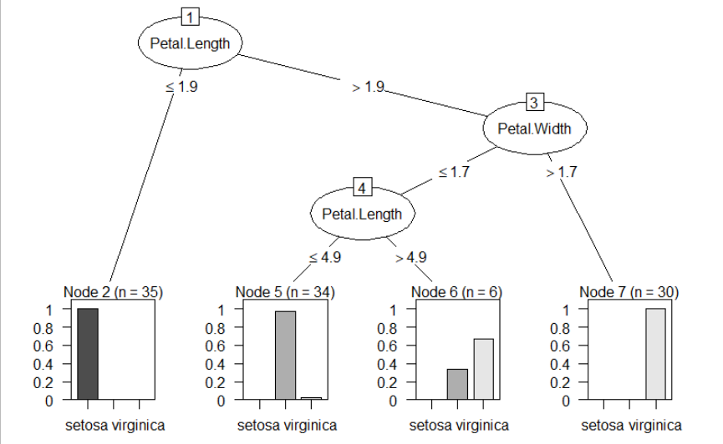

Boosting

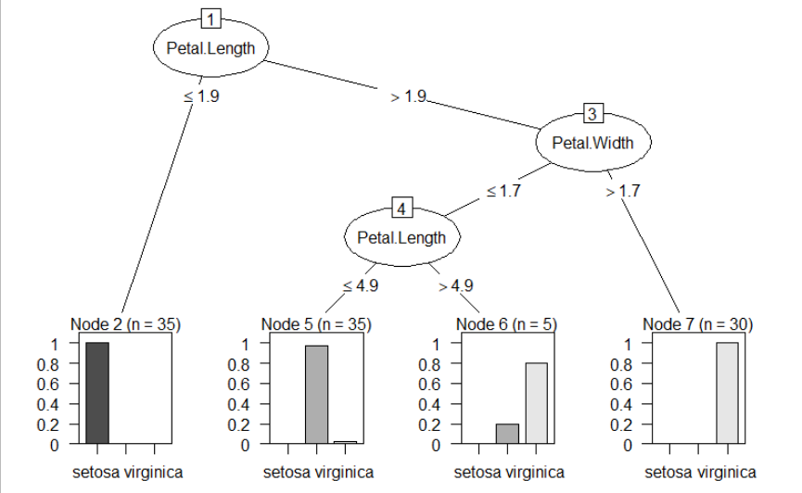

Bagging

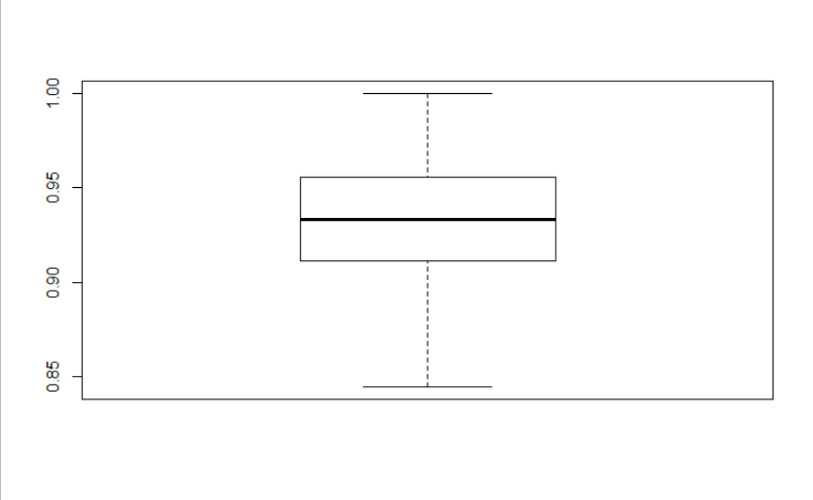

Bagging & Boosting

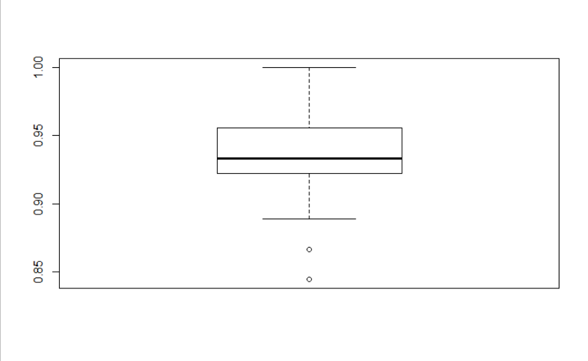

**Inference :**

Petal Length was found as the important feature and was considered as the root node.